Curriculum Newsletter Summer Term 2  This half term Class Wear will be learning all about… |  |   Gainford C of E Primary
English  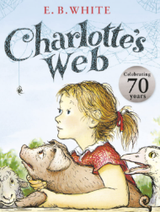  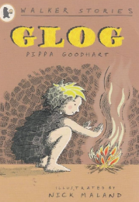  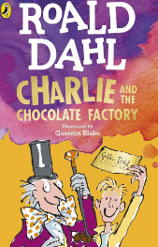  In our upcoming English lessons, we have an exciting range of activities planned! We’ll be diving into narrative writing by creating our own stories inspired by Charlie and the Chocolate Factory, using our imaginations to invent magical settings and quirky characters. Alongside this, we’ll be working on our non-fiction writing skills by producing a chronological report all about earthquakes. In guided reading, we’ll be exploring the book Glog, discussing its themes and language in detail. For our reading for pleasure sessions, we’ll continue enjoying the much-loved classic Charlotte’s Web. It’s set to be a busy and brilliant term of reading and writing!  RE  In RE this term, we’ll be exploring the question: How and why do people make the world a better place? We’ll be learning about different beliefs, values, and actions from a range of religions and worldviews and discussing the ways people show kindness, help others, and work towards positive change in their communities and beyond.  MFL    In our upcoming French lessons, we will be exploring the exciting topic of "Going on a Picnic." This fun and engaging unit will help students learn how to talk about different types of food and drink in French, as well as how to describe where they live. Through a variety of interactive activities, pupils will build their vocabulary, improve their speaking and listening skills and gain confidence using French in everyday contexts. | Maths  In Maths this term, we’ll be covering a wide range of important topics. We’ll begin by learning all about time, including how to tell the time to the nearest minute using both analogue and digital clocks, as well as understanding the 24-hour clock. We’ll also be developing our knowledge of decimals and money, applying these skills in real-life contexts. Later in the term, we’ll be exploring shape, position and direction, and learning how to interpret and present data in our statistics lessons. It’s going to be a packed term full of hands-on learning and problem-solving!  Computing  In Computing this term, we’ll be developing our digital skills through a variety of exciting projects. We’ll learn how to create engaging presentations using both PowerPoint and Google Slides, focusing on layout, design and clear communication. We’ll also be introduced to Microbits, using simple coding to bring these mini computers to life. In addition, we’ll be creating virtual graphs to help us present data clearly and effectively.  DT  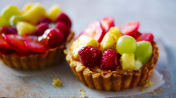  In DT this term, our focus will be on Cooking and Nutrition. We’ll be learning all about eating seasonally, discovering which foods are in season at different times of the year and why this is important. Using this knowledge, we’ll put our skills into practice by designing and creating our own delicious seasonal food tarts. It’s going to be a tasty and informative term!! | Science  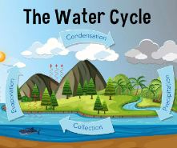    In Science, we’ll be learning all about changes in state, exploring how materials can change between solids, liquids, and gases. We’ll also be investigating the water cycle, understanding how processes like evaporation and condensation play a part in it. Throughout our lessons, we’ll be practicing our working scientifically skills—carrying out experiments, making predictions, recording results and drawing conclusions.  PE  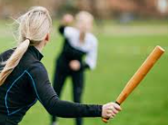  In PE this term, we’ll be focusing on athletics and rounders, building our skills in running, jumping, throwing and teamwork. We’re also looking forward to Sports Day, where we’ll have the chance to put our practice into action and enjoy some friendly competition. Please note that our new PE days are Tuesday and Friday, so make sure you have your kit on those days.  Jigsaw    Our PSHE Jigsaw topic is all about Changing Me. We will be learning all about how babies grow, outside body changes, inside body changes, family stereotypes and looking ahead.
 | Geography  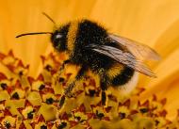  In Geography this term, we’ll be exploring Sustainable Environments. Our big question will be: How do we meet human needs and protect the planet? We’ll look at the challenges of feeding the world sustainably, including the vital role bees play in our ecosystems. Through this topic, we’ll also develop our understanding of location and place and practice important decision-making skills as we think about how to care for our environment while supporting communities around the world. | Music  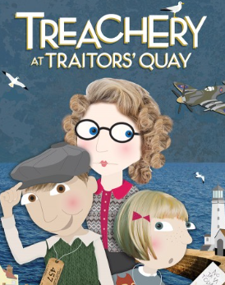  In Music this term, we’ll be busy practicing for our exciting summer production, Treachery at Traitors’ Quay. We’ll be learning the songs, rehearsing our performances and working together to bring the story to life on stage. It’s a fantastic opportunity to build our confidence, have fun and showcase our musical and dramatic talents!
01325 730274 admin@gainfordcofeprimary.co.uk www.gainfordcofeprimary.co.uk

