EYFS Curriculum Overview – Gainford C of E Primary and Preschool 2026 - 2027
 | 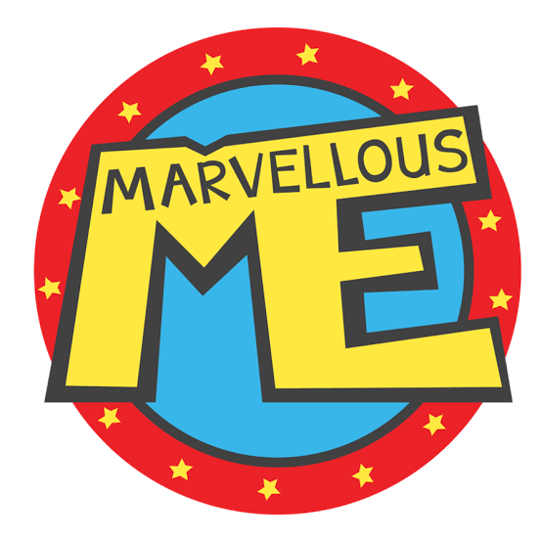  Autumn Term 1 | 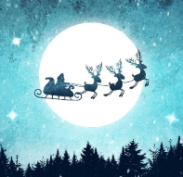  Autumn Term 2 |   Spring Term 1 | 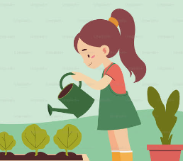  Spring Term 2 |   Summer Term 1 |   Summer Term 2
Theme | Marvellous Me / Autumn Treasures | Celebrations & Festivals / Preparing for Christmas | Wonderful World / People Who Help Us | Come Outside | Let’s Investigate | Journeys
Examples of Possible Learning Opportunities  (please note - not all of these would be covered, one or two depending on children’s interests) | My Family  My Body  My feelings  Where we live  Things I like  Belonging  Harvest  Autumnal Changes | Birthdays  Christmas around the world  Diwali  Bonfire Night  Remembrance Day  Christmas | Arctic Environments  Dinosaurs  Digging / Fossils  Volcanoes  Deserts | Life cycles  Habitats  Outdoors  Minibeasts  Spring | Floating and Sinking  Changes  Our Senses  Forces  Minibeasts  Changes | Land and Sea Journeys  Transport  Holidays  Pirates  Mermaids  Summer  Seaside
Theme Texts | 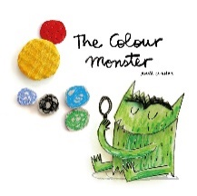  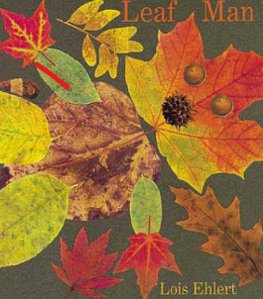 | 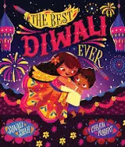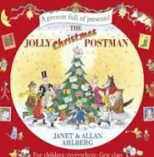 | 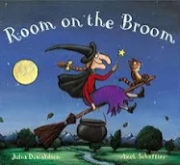  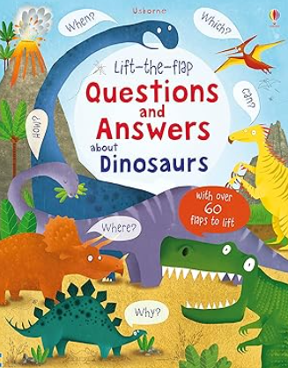 | 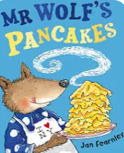  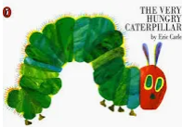 | 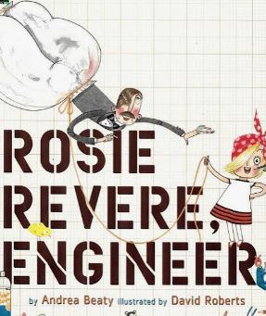  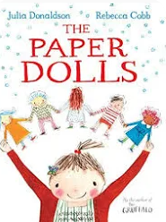 | 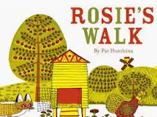  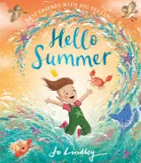

At Gainford C of E Primary School our curriculum is designed to develop confident, curious and independent learners through meaningful play, high-quality interactions and carefully sequenced teaching.
Our curriculum is rooted in the Statutory EYFS Framework and has been designed to meet the needs of our children. It balances adult-led teaching with high-quality continuous provision, ensuring children revisit and apply learning throughout their play.
What We Value in Our EYFS
- Christian Values & Inclusion: Guided by our core values—such as being caring, supportive, inclusive, and respectful—we foster a warm community where unique starting points are celebrated and all children are empowered to flourish.
- A Love of the Outdoors & Forest School: We strongly value the natural world as an inspiring context for learning. Through our dedicated outdoor provision and Forest School sessions, children develop resilience, take managed risks, explore living things, and build a lifelong connection to the environment.
- "Making Magic" and Wonder: We believe in igniting a true sense of awe, curiosity, and imagination. By immersing children in rich storytelling, high-quality interactions, and magical, hands-on experiences, we turn everyday learning into unforgettable adventures.
- The Power of Play: Guided by skilled adults, our enabling indoor and outdoor environments encourage children to direct their own play, make choices, think critically, and apply newly acquired skills independently.
By weaving together the structure of the EYFS framework, the magic of the natural world, and our deeply rooted school ethos, we lay the absolute right foundations for every child to thrive as they embark on their educational journey.

PSED  Personal, Social & Emotional Development | PERSONAL, SOCIAL AND EMOTIONAL DEVELOPMENT – Prime Area
PSED  Personal, Social & Emotional Development | Children’s personal, social and emotional development (PSED) is crucial for children to lead healthy and happy lives and is fundamental to their cognitive development. Underpinning their personal development are the important attachments that shape their social world. Strong, warm and supportive relationships with adults enable children to learn how to understand their own feelings and those of others. Children should be supported to manage emotions, develop a positive sense of self, set themselves simple goals, have confidence in their own abilities, to persist and wait for what they want and direct attention as necessary. Through adult modelling and guidance, they will learn how to look after their bodies, including healthy eating, and manage personal needs independently. Through supported interaction with other children, they learn how to make good friendships, co-operate and resolve conflicts peaceably. These attributes will provide a secure platform from which children can achieve at school and in later life.
PSED  Personal, Social & Emotional Development | Autumn Term 1 | Autumn Term 2 | Spring Term 1 | Spring Term 2 | Summer Term 1 | Summer Term 2
PSED  Personal, Social & Emotional Development | Marvellous Me / Autumn Treasure | Celebrations & Festivals / Preparing for Christmas | Wonderful World / People Who Help Us | Come Outside | Let’s Investigate | Journeys
Jigsaw  PSHE | BM (Being Me in My World)  'Who am I and how do I fit?' | CD (Celebrating Difference)  Respect for similarity and difference. Anti-bullying and being unique | DG (Dreams and Goals)  Aspirations, how to achieve goals and understanding the emotions that go with this | HM (Healthy Me)  Being and keeping safe and healthy | RL (Relationships)  Building positive, healthy relationships | CM (Changing Me)  Coping positively with change
Core  Theme | Living in the Wider World |  | Health and Wellbeing |  | Relationships
 | Children should have the opportunity to develop an understanding of caring for ourselves and others, a sense of belonging and community, to understand positive behaviour and expectations within our classroom, and being an active part of the classroom community |  | Children should have the opportunity to develop an awareness of healthy lifestyles, personal care and wellbeing, including hygiene, exercise, rest and nutrition. They will begin to understand growing and changing, increasing independence, keeping ourselves and others safe, and developing an awareness of our bodies and individual similarities and differences. |  | Children should have the opportunity to understand special relationships with family, friends and others, including caring for one another, listening and cooperating. Exploring ways to manage disagreements and developing an awareness of how our actions can affect others.
ELGs | ELG: Self-Regulation  Children at the expected level of development will:  - Show an understanding of their own feelings and those of others and begin to regulate their behaviour accordingly.  - Set and work towards simple goals, being able to wait for what they want and control their immediate impulses when appropriate.  - Give focused attention to what the teacher says, responding appropriately even when engaged in activity, and show an ability to follow instructions involving several ideas or actions.  ELG: Managing Self  Children at the expected level of development will:  - Be confident to try new activities and show independence, resilience and perseverance in the face of challenge.  - Explain the reasons for rules, know right from wrong and try to behave accordingly.  - Manage their own basic hygiene and personal needs, including dressing, going to the toilet and understanding the importance of healthy food choices.  ELG: Building Relationships  Children at the expected level of development will:  - Work and play cooperatively and take turns with others.  - Form posive attachments to adults and friendships with peers.  - Show sensitivity to their own and to others’ needs.

CL  Communication  & Language | Autumn Term 1 | Autumn Term 2 |  | Spring Term 1 | Spring Term 2 | Summer Term 1 |  | Summer Term 2
Themes | Marvellous Me / Autumn Treasure | Celebrations & Festivals / Preparing for Christmas |  | Wonderful World / People Who Help Us | Come Outside | Let’s Investigate |  | Journeys
Speaking | - Begin to use longer sentences, sometimes using and because.  - Talk about something that has happened yesterday  - Ask lots of questions and answer questions.  - Talk about what they are doing now and what might happen later or tomorrow.  - Sometimes I can make myself really clear when I am trying to tell you something.  Use lots of new vocabulary about things that interest me. |  | - Use a range of vocabulary to tell you about something I have made or done.  - Use new words whilst I’m playing.  - Pretends to be different people with appropriate dialogue.  - Use words such as first, next, last when they tell you what they have done. Make up stories using what I know.  - Make up silly rhymes.  Use alliteration (simple) Use different voices when telling stories. |  |  |  | - Participate in small group, class and 1 to 1 discussions offering their own ideas, using new vocabulary.  - Offer explanations for why things might happen, making use of new vocabulary from stories, nonfiction, rhymes and poems where appropriate  - Express their ideas about their experiences using full  sentences, including use of past, present and future tenses and making use of conjunctions, with modelling and support from their teacher.  - Being Imaginative and expressive – Links to speaking ELG  - Invent, adapt and recount narratives and stores with their teacher and peers.  - Perform songs, rhymes, poems and stories with others.
Language / speech  development / provision | Daily opportunities for high-quality interactions, sustained shared thinking, Drawing Club, story times, small-group discussions and adult modelling develop children's vocabulary, sentence structure, listening and conversational skills. Adults explicitly teach and revisit new vocabulary throughout the day.
Listening, attention and understanding  (Development Matters) | Through adult directed and independent activities, children have opportunities develop listening, attention and understanding in the following ways:  - Understand how to listen carefully and why listening is important.  - Learn new vocabulary. Use new vocabulary throughout the day.  - Ask questions to find out more and to check they understand what has been said to them.  - Articulate their ideas and thoughts in well-formed sentences.  - Connect one idea or action to another using a range of connectives.  - Describe events in some detail.  - Use talk to help work out problems and organise thinking and activities explain how things work and why they might happen.  - Develop social phrases.  - Engage in story times.  - Listen to and talk about stories to build familiarity and understanding.  - Retell the story, once they have developed a deep familiarity with the text, some as exact repetition and some in their own words.  - Use new vocabulary in different contexts.  - Listen carefully to rhymes and songs, paying attention to how they sound.  - Learn rhymes, poems and songs.  - Engage in non-fiction books.  - Listen to and talk about selected non-fiction to develop a deep familiarity with new knowledge and vocabulary.
ELGs | Communication and Language  Listening, Attention and Understanding  Children at the expected level of development will:  - Listen attentively and respond to what they hear with relevant questions, comments and actions when being read to and during whole class discussions and small group interactions.  - Make comments about what they have heard and ask questions to clarify their understanding.  - Hold conversation when engaged in back-and-forth exchanges with their teacher and peers.  Speaking  Children at the expected level of development will: •  - Participate in small group, class and one-to-one discussions, offering their own ideas, using recently introduced vocabulary.  - Offer explanations for why things might happen, making use of recently introduced vocabulary from stories, non-fiction, rhymes and poems when appropriate.  - Express their ideas and feelings about their experiences using full sentences, including use of past, present and future tenses and making use of conjunctions, with modelling and support from their teacher.

Literacy | Autumn Term 1 | Autumn Term 2 | Spring Term 1 | Spring Term 2 | Summer Term 1 |  | Summer Term 2
Themes | Marvellous Me / Autumn Treasure | Celebrations & Festivals / Preparing for Christmas | Wonderful World / People Who Help Us | Come Outside | Let’s Investigate |  | Journeys
Texts to Support our Topic  *subject to change dependent on children’s interests | 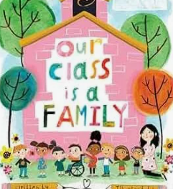
Drawing Club Literacy Texts  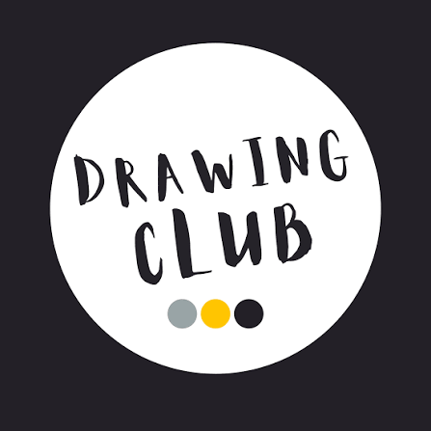  Book  Tale  Animation | Building Relationships / Getting to know the children  Dear Zoo  The Enormous Turnip  Mr Benn - Zookeeper | ​  We’re going on a bear hunt  The Gingerbread Man  Wacky Races  Stickman  Three Little Pigs  The Snowman | Not now Bernard  ​  Chicken Licken  Bananaman  Where the Wild Things Are  Goldilocks and the 3 Bears  Poddington Peas | The Giant Jam Sandwich  Three Billy Goats Gruff  Pingu  Little Rabbit Foo Foo  Little Red Hen  Rugrats | Stuck  ​  Little Red Riding Hood  ​ ​  Rugrats  Daisy Eat your Peas  Jack and the Beanstalk  Roadrunner |  | The Tiger who Came to Tea  Magic Porridge Pot  Batfink  The 100 Decker Bus  Hansel and Gretel  TopCat
Story time texts | Age 3-4  We’re Going on a Leaf Hunt, Fletcher’s Leaves, Autumn, The Leaf Man,  Books about Harvest,  Nursery Rhymes  RECEPTION  Funny Bones  The Mega Magic Hair Swap Only One You All Kinds of People  Happy in Our Skin  The Name Jar  Whoever you are What happened to you?  Super Duper You!  Tree: Seasons Come, Seasons Go  Pumpkin Soup  Autumn / Ourselves / People Who Help Us – Topic Box including non-fiction DLR | Age 3-4  Lost and Found, Little Penguin Lost, The Not So Brave Penguin, Be Brave Little Penguin, The Snowman,  RECEPTION  Wonderland Polar Express Christmas Jolly Postman  Stick Man  The Great Explorer  Papa Penguin  The Snowflake  Time to Move South for Winter  I Definitely Don’t Like Winter Winter / Christmas– Topic Box including non-fiction DLR | Age 3-4  Aliens Love Underpants Seven ways to Catch A Moon The Smeds and Snoods Goodnight Spaceman Zoom Rocket Zoom, How to Catch a Star The Way Back Home On the Moon  Whatever Next  RECEPTION  Whatever Next!  Q Pootle5  How to Catch a Star  The Way Back Home Rain Before Rainbows Astro Girl  Look Up Beegu  Neil Armstrong  Mae Jemison  Counting on Katherine Here We Are  One Giant Leap  Man on the Moon  Space – Topic Box including non-fiction DL | Age 3-4  The Rainbow Fish The Colour Monster, Elmer Little Red Riding Hood, Mouse Paint Matisse’s Magical Snail Noah’s Ark Bears Love Colour  RECEPTION  The Colour Monster The Day the Crayons Quit (series)  The Crayons’ Book of Colours  Brown Bear Brown Bear Mixed  Elmer and the Rainbow How to Catch a Rainbow  How Do You Make a Rainbow?  The World Made a Rainbow  Colours, Colours Everywhere Colour Chinese New Year / Spring –Topic Box including non-fiction DLR | Age 3-4  Billy Goats Gruff Three Little Pigs Goldilocks and the Three bears (Beware of the Bears), The Magic Porridge Pot (The Magic Pasta Pot), The Little Red Hen, Jack and the Beanstalk  RECEPTION  On the Way Home  You Choose Fairy Tales Traditional Tales – Goldilocks / The 3 Little Pigs  The 3 Billy Goats Gruff  The Gingerbread Man  The Little Red Hen  Chicken Licken  The Princess and the Pea etc. The Tiger Who Came to Tea The Great Fairy tale Disaster Mixed Up Fairy Tales Traditional Tales / Rhymes - Topic Box DLR |  | Age 3-4  The Tiny Seed Oliver’s Vegetables Kipper’s Beanstalk, Peter Rabbit, Superworm, My Garden Harry’s Garden Yucky Worms  The Very Hungry Caterpillar, Jack and the Beanstalk,  RECEPTION  Jack and the Beanstalk  Jim and the Beanstalk  The Enormous Turnip Oliver’s Vegetables  Fruit Salad  Grandpa’s Garden  Eco Girl  The Secret Sky Garden  I am the Seed that Grew the Tree  The Tiny Seed  The Very Hungry Caterpillar Growing Frogs Plants / Minibeasts / Lifecycles / Summer – Topic Box including non-fiction DLR
​  Rhymes and Songs​  ​  Age 3-4​  ​  ​  ​ | Rhymes containing short sentences and/ or slower paced:​  ​  Humpty Dumpty​  Baa baa black sheep​  Twinkle Twinkle Little Star​  Row, row row your boat​  Rain, rain go away​  Pat a cake​  Little Miss Muffett​  Star light Star bright​  Jack and Jill​  Polly put the kettle on​ | Action Songs:​  ​  Brush your teeth​  Heads Shoulders knees and toes​  If you’re happy and you know it​  Sleeping bunnies​  Dingle dangle Scarecrow​  Wind the bobbin up​  The Farmer’s in his den​ | Rhymes containing longer sentences:​  The Grand Old Duke of York​  This little piggy went to market​  The bear went over the mountain​  Down in the jungle​  Incy wincy spider​  I’m a little teapot​  The wheels on the bus​  Old McDonald had a farm​  Miss Molly had a dolly​  Mary had a little lamb​ | Counting Songs: ​  5 little Speckled frogs​  5 Little Ducks​  5 little men in a flying saucer​  1,2,3,4,5 once I caught a fish alive​  Two little dickie birds​  Three Blind Mice​  5 current buns​  5 Little monkeys jumping on the bed​  One finger one thumb​  ​  ​  ​  ​ |  |  | Rhymes containing short sentences and/ or slower paced:​  ​  Humpty Dumpty​  Baa baa black sheep​  Twinkle Twinkle Little Star​  Row, row row your boat​  Rain, rain go away​  Pat a cake​  Little Miss Muffett​  Star light Star bright​  Jack and Jill​  Polly put the kettle on​
Rhymes and Songs​  ​  Reception​  ​ | Recap from Spring/Summer​ | Variation of songs from Nursery:​  ​  Twinkle, twinkle chocolate bar​  Incy, wincy spider climbed up a tree​  Baba blue sheep​  5 little monkeys swinging from a tree​  ​ | Counting Songs:​  ​  1,2, buckle my shoe​  Ten Green Bottles​  Ten in a bed​  10 fat sausages​  This old man​  One potato, two potato​  Hickory dickory dock​  One finger, one thumb​  ​ | Complex Language:​  ​  Mary Mary, quite contrary​  Goosy goosy gander​  The big ship sails​  Dr Foster went to Gloucester​  I know an old lady who swallowed a fly​  Here we go round the Mulberry bush​  ​  ​ |  | Cultural Songs and Rhymes:​  ​  Frere Jacques​  Ring a ring of roses​  Hot cross buns​  Are you sleeping?​  Oranges and lemons​  London Bridge is falling down​  The animals went in two by two​  Jambo​  Bobby Shaftoe’s gone to sea​

Phonics  Sounds Write |  | THE INITIAL CODE  Skills:  To segment, blend and manipulate sounds in words with the structure: CVC  Code:  Unit 1 a,i,m,s,t  Unit 2 n,o,p  Unit 3 b, c, g, h  Unit 4 d, e, f, e  Unit 5 k, l, r, u  Unit 6 j, w, z  Unit 7 x, y, ff, ll, ss, zz  Conceptual knowledge:  Sounds can be represented by spellings with one letter  Unit 7 – Some spellings are written with double consonants  High Frequency words introduced:  Is, a, the, I, for, of, off, are, was, all |  |  |  |  | THE INITIAL CODE  Skills:  To segment, blend and manipulate sounds in words with the structure:  VCC & CVCC-2 consonants in the final position. 3- & 4- sound words  Code – No new code knowledge  Unit 8 VCC and CVCC  Unit 9 CCVC – 2 consonants in initial position  Unit 10 CCVC, CVCCC, and CCCVC – 3 adjacent consonants 5-sound words  Unit 11 sh, ch, th, ck, wh, ng, <q> <u>  Conceptual knowledge:  Some spellings are written with two different letters <q> and <u> represent the sounds /k/ and /w/  Assess students before moving onto the next units  High Frequency words introduced:  Come, some, to  < th> their, these, <wh> what, where, who |  |  |  |  | THE INITIAL CODE  Consolidation Bridging Lessons  Skills:  To segment, blend and manipulate sounds in words up to 5-sound words.  Code:  Unit 11 sh, ch, th, ck, wh, ng, <q> <u>  Conceptual knowledge:  Some spellings are written with two different letters <q> and <u> represent the sounds /k/ and /w/
High Frequency & Common  Exception  Words (CEW ) |  | By the end of the Initial Code pupils will be able to read thirty-two of the first 100 high-frequency words (see below) shown in the list by decoding them. Until they are covered in the programme, whenever they appear in text, tell the pupils what sound(s) the unknown spelling(s) represent(s) to allow them to decode the word for themselves. For example, if a pupil, working in the Initial Code at around Unit 7 or Unit 8, is trying to read the word 'back' but hasn’t yet been introduced to the spelling alternative for /k/, the teacher runs their pencil under the and says, “This is one sound. It’s /k/. Say /k/ here.”  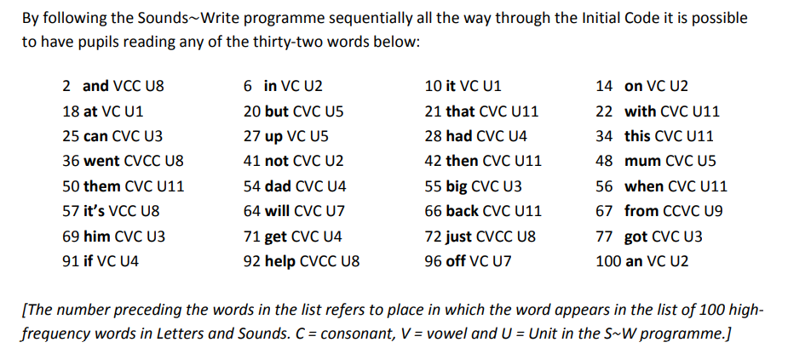
Reading  Assessment focus  (in bold) |  | - Sing nursery rhymes and songs. Join in with rhymes.  - Recognise alliteration at a basic level.  - Clap out 2-3 syllable.  - Join in with favourite stories.  - Predict what will happen next in a story. Know that stories have a beginning, middle and end. Listen to stories and talk about them. Discuss the settings and characters as well as the important events in a story.  - Recognise their own name and words that are important to them such as mam, favourite foods and shops.  - Hold books the correct way up and treat books carefully.  - Know that books can give information.  - Know that the words can tell you information.  Autumn  - Read individual letters by saying the sounds for them. |  |  |  |  | - Identify words that rhyme.  - Hear and say the initial sound in words when a word is said to them.  - Sound out each of the sounds and put them together to read a word.  - Read short sentences.  - Use favourite stories to help children create their own stories.  - Share a range of books, comics, stories, rhymes, poems, fact books, and magazines.  - Look in books to find information. Read signs.  - Choose their own books.  - Identify rhyming words.  Spring Checkpoint Assessment:  - Blend sounds into words, so that they can read short words made up of known letter-sound correspondences.  - Read some letter groups that each represent one sound and say the sounds for them.  - Read a few common exception words matched to the school’s phonics programme.  - Read simple phrases and sentences made up of words with known letter sounds and correspondences and where necessary, a few exception words.  - Re-read these books to build up their confidence in word reading, their fluency and their understanding and enjoyment. |  |  |  |  | Summer Assessment (ELG) -  Comprehension  - Demonstrate understanding of what has been read to them by retelling stories and narratives using their own words and recently introduced vocabulary.  - Anticipate key events in stories.  - Use and understand recently introduced vocabulary during discussion about stories, non-fiction, rhymes and poems and during role play.  Word Reading  - Says a sound for each letter in the alphabet for at least 10 diagraphs.  - Read words consistent with their phonic knowledge by sound blending.  - Read aloud simple sentences and books that are  - consistent with their phonics knowledge, including some common exception words.
Whole class reading |  | - Drawing Club weekly core text - a story per week as a focus for language, new vocabulary and writing activities  - Poems / rhymes / non-fiction and fiction books balanced across the week and used to embed new words.  - Daily Storytimes  - Guided reading comprehension through high quality questioning.  - Non-fiction used at the start of a topic to introduce technical vocabulary
Individual  Reading  (Decodable Readers) |  | - This set is comprised of thirteen 8-page books and one sixteen-page book. These match the Units 1 – 11 of the initial code. Reception children will read through all of these before moving onto the Extended Code in Y1.  - Dandelion Readers are decodable reading books in line with the Sounds Write Units. Set 2 and 3 are books following the units, but have and increased number of words per page, which allows for slight differentiation and variation when continuing on the same unit.  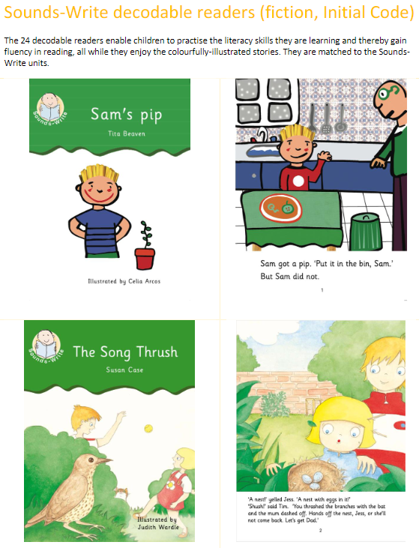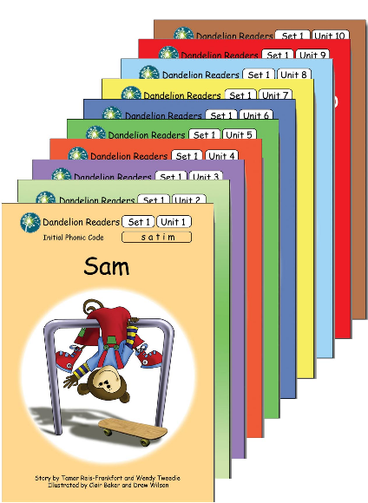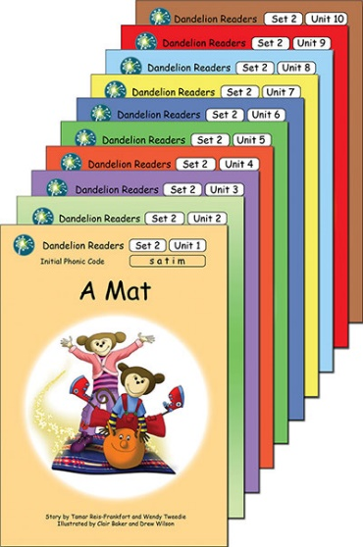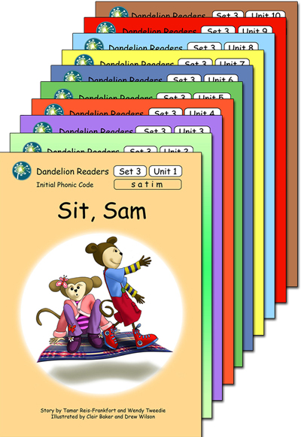  - This set is comprised by ten sixteen-page readers, these are all our titles for the Initial Code Units 8 - 11.  Other independent reading:  - Read and Relax area in the Reception environment.  - Outdoor read and relax area.  - Resources labelled with pictures / words
Modelled reading/ parent support |  | - Weekly reading book closely matched to phonic stage.  - Sounds Write Workshop/ information sent home for parents  - Letter join – handwriting/ letter formation practise sent home as weekly home work
Writing  Writing Assessment |  | - Sometimes, they can identify what their paintings or drawing mean.  - When they see writing, they can say what they think it means.  - Make lines and marks with a pencil. Copy some of the letters of their name.  - Use ISHA programme to teach letter formation and send home sounds/ letters to practise. (Linked to Sounds Write phonics lessons). |  |  |  |  | - Say what the marks, letters and pictures they make mean.  - Know that when a word is written down and the letters used make a word I have said.  - Say each sound in a short word and put them together to say the word.  - Know the names of the letters of the alphabet.  - Begin to use letters in writing.  - Write their own name.  - Try to write short sentences.  - Word writing – initial sounds.  Spring assessment check  - Form lower case and capital letters correctly  - Spell words by identifying the sounds and then writing the sound with letter/s  - Write short sentences with words with known letter-sound correspondences using a capital letter and full stop.  - Re-read what they have written to check it makes sense. |  |  |  |  |  | Summer assessment ELG – Writing  - Write recognisable letters, most of which are correctly formed.  - Spell words by identifying sounds in them and representing the sounds with a letter or letters.  - Write simple phrases and sentences that can be read by others.  - Begin to write some CEW Write first name and surname.
Teacher led writing opportunities |  | - Writing linked to the core texts as listed above via Drawing Club.  - Letter formation / handwriting practice following the ‘ISHA’ programme.
ELG |  | ELG: Comprehension  Children at the expected level of development will:  - Demonstrate understanding of what has been read to them by retelling stories and narratives using their own words and recently introduced vocabulary.  - Anticipate – where appropriate – key events in stories.  - Use and understand recently introduced vocabulary during discussions about stories, non-fiction, rhymes and poems and during role-play.  ELG: Word Reading  Children at the expected level of development will:  - Say a sound for each letter in the alphabet and at least 10 digraphs.  - Read words consistent with their phonic knowledge by sound-blending.  - Read aloud simple sentences and books that are consistent with their phonic knowledge, including some common exception words.  ELG: Writing  Children at the expected level of development will:  - Write recognisable letters, most of which are correctly formed.  - Spell words by identifying sounds in them and representing the sounds with a letter or letters.  - Write simple phrases and sentences that can be read by others.
Maths   | Autumn Term 1 |  |  | Autumn Term 2 |  | Spring Term 1 |  |  | Spring Term 2 |  | Summer Term 1 |  |  |  | Summer Term 2
 | Marvellous Me / Autumn Treasure |  |  | Celebrations & Festivals / Preparing for Christmas |  | Wonderful World / People Who Help Us |  |  | Come Outside |  | Let’s Investigate |  |  |  | Journeys
White Rose Maths | Getting to know you  Match, sort and compare  Baseline Assessments |  | Talk about measures and patterns  Baseline Assessments | It’s me 123!  Circles and triangles | 1,2,3,4,5  Shapes with 4 sides | Alive in 5  Mass and capacity  Growing  6, 7, 8 |  |  | Length, height and time  Building 9 & 10  Explore 3D shapes |  | To 20 and beyond  How many now?  Manipulate, compose and decompose |  |  | Sharing and grouping | Visualise, build and map | Make connections
Number | Opportunities for settling in, introducing the areas of provision and getting to know the children |  | Match and sort  Compare amounts | Representing 1,2,& 3  Comparing 1,2,& 3  Composition of 1,2 & 3 | Representing numbers to 5  One more and less | Introducing zero  Comparing numbers to 5  Composition of 4 & 5 |  | 6,7,& 8  Combining 2 amounts  Making pairs |  | Counting to 9 & 10  Comparing numbers to 10  Bonds to 10 | Building numbers beyond 10  Counting patterns beyond 10 |  |  | Adding more  Taking away | Doubling  Sharing and Grouping  Even and odd | Deepening Understanding  Patterns and relationships
Measure, shape and special thinking | Key times of the day, class routines. Exploring the continuous provision inside and out. Where do things belong?  Positional language |  | Compare size, mass and capacity | Circles and triangles  Positional language | Shapes with 4 sides  Time | Compare Mass (2)  Compare Capacity (2) |  | Length and height  Time |  | 3D Shapes  Patterns | Spatial Reasoning (1)  Match, rotate, manipulate |  |  | Spatial reasoning (2) | Spatial Reasoning (3)  Visualise and build | Spatial Reasoning (4)  Mapping
ELG | Mathematics ELG: Number  Children at the expected level of development will:  - Have a deep understanding of numbers to 10, including the composition of each number.  - Subitise (recognise quantities without counting) up to 5.  - Automatically recall (without reference to rhymes, counting or other aids) number bonds up to 5 (including subtraction facts) and some number bonds to 10, including double facts.  ELG: Numerical Patterns  Children at the expected level of development will:  - Verbally count beyond 20, recognising the pattern of the counting system.  - Compare quantities up to 10 in different contexts, recognising when one quantity is greater than, less than or the same as the other quantity.  - Explore and represent patterns within numbers up to 10, including evens and odds, double facts and how quantities can be distributed equally.

PD  Physical Development | Autumn Term 1 | Autumn Term 2 |  | Spring Term 1 | Spring Term 2 |  | Summer Term 1 | Summer Term 2
PD  Physical Development | Marvellous Me / Autumn Treasure | Celebrations & Festivals / Preparing for Christmas |  | Wonderful World / People Who Help Us | Come Outside |  | Let’s Investigate | Journeys
PE  Lessons | Me & Myself | Movement & Development |  | Throwing & Catching | Ball Skills |  | Fun & Games | Working with Others
Intent | Physical Development is woven throughout daily life in Reception. Children develop gross and fine motor skills through a balance of adult-led PE, carefully planned continuous provision and everyday routines. Opportunities are provided to build strength, coordination, balance, spatial awareness and control while developing the fine motor skills needed for writing and self-care.  Learning is revisited throughout continuous provision, adult-led teaching and purposeful play.
Physical Development – daily across the year | Gross Motor Development  Children have daily opportunities to:  - develop balance and coordination  - negotiate space safely  - climb, balance and travel confidently  - throw, catch, roll and kick balls  - develop core strength and stability  - move in different ways with increasing control  - take part in cooperative games and physical challenges  Learning is supported through PE lessons, outdoor provision, obstacle courses, wheeled toys, climbing equipment, construction, dance, movement activities and child-initiated play. |  | Fine Motor Development  Daily opportunities enable children to:  - develop hand strength and dexterity  - use a range of tools safely and effectively  - strengthen pencil control  - develop the tripod grip  - build independence for writing and self-care  Provision includes malleable materials, threading, cutting, construction, drawing, painting, mark making and other practical activities that promote hand and finger strength. |  |  | Self-Care  Children develop increasing independence through everyday routines including:  - dressing and undressing  - managing fastenings  - toileting  - handwashing  - snack and mealtimes  - organising personal belongings  - changing for PE
ELG | ELG:  Gross Motor Skills Children at the expected level of development will:  - Negotiate space and obstacles safely, with consideration for themselves and others.  - Demonstrate strength, balance and coordination when playing.  - Move energetically, such as running, jumping, dancing, hopping, skipping and climbing.  ELG:  Fine Motor Skills Children at the expected level of development will:  - Hold a pencil effectively in preparation for fluent writing – using the tripod grip in almost all cases.  - Use a range of small tools, including scissors, paint brushes and cutlery.  - Begin to show accuracy and care when drawing.

UTW  Understanding the World | Autumn Term 1 | Autumn Term 2 | Spring Term 1 |  | Spring Term 2 | Summer Term 1 |  |  | Summer Term 2
UTW  Understanding the World | Marvellous Me / Autumn Treasure | Celebrations & Festivals / Preparing for Christmas | Wonderful World / People Who Help Us |  | Come Outside | Let’s Investigate |  |  | Journeys
Intent | Children develop an understanding of the world through first-hand experiences, high-quality texts, visitors, outdoor learning and meaningful discussions. Learning begins with children's own lives before gradually extending to the local community and the wider world. The curriculum encourages curiosity, enquiry and respect for people, places and the natural environment.  Learning is revisited throughout continuous provision, adult-led teaching and purposeful play.
 | Past and Present  Children will have opportunities to:  - talk about themselves and their families  - compare past and present  - learn about people who help us  - explore significant events through stories and celebrations  - begin to understand how life has changed over time |  |  | People, Culture and Communities  Children will:  - learn about their local community  - explore different celebrations and traditions  - compare life in this country with other places  - develop respect for similarities and differences  - use stories, maps and photographs to develop geographical understanding |  |  | The Natural World  Children investigate the natural world through:  - seasonal change  - plants and animals  - habitats  - life cycles  - outdoor exploration  - simple investigations  - caring for the environment  - Weekly Forest School
ELG | ELG Past and Present  Children at the expected level of development will:  - Talk about the lives of the people around them and their roles in society.  - Know some similarities and differences between things in the past and now, drawing on their experiences and what has been read in class. •  - Understand the past through settings, characters and events encountered in books read in class and storytelling. |  |  | ELG People, Culture and Communities  Children at the expected level of development will:  - Describe their immediate environment using knowledge from observation, discussion, stories, non-fiction texts and maps.  - Know some similarities and differences between different religious and cultural communities in this country, drawing on their experiences and what has been read in class.  - Explain some similarities and differences between life in this country and life in other countries, drawing on knowledge from stories, non-fiction texts and – when appropriate – maps. |  |  | ELG The Natural World  Children at the expected level of development will:  - Explore the natural world around them, making observations and drawing pictures of animals and plants.  - Know some similarities and differences between the natural world around them and contrasting environments, drawing on their experiences and what has been read in class.  - Understand some important processes and changes in the natural world around them, including the seasons and changing states of matter.
RE | F1 Why is the word God so important to Christians?  - The word God is a name  - Christians believe God is the creator of the universe  - Christians believe God made our wonderful world so we should look after it  F2 Why do Christians perform Nativity plays at Christmas?  - Christians believe God came to Earth in human form as the Baby Jesus  - Christians believe Jesus came to show that all people are precious and special to God |  |  | F4: Being special: Where do we belong?  - Retell religious stories making connections with personal experiences  - Share and record occasions when things have happened in their lives that made them feel special  - Recall simply what happens at a traditional Christian infant baptism and dedication  - Recall simply what happens when a baby is welcomed into a religion other than Christianity.  F3 Why do Christians put a cross on an Easter Garden?  - Christians remember Jesus’ last week at Easter  - Jesus’ name means ‘He saves us’  - Christians believe Jesus came to show God’s love  - Christians try to show love to others |  |  |  | F6 Which stories are special and why?  - Talk about and recall about some religious stories  - Identify some of my own feelings in the stories they have heard.  - Identify a scared text e.g. Bible or the Qu ‘ran  - Talk about things these stories teach believers.  F5 Which places are special and why?  - Show an awareness that some religious people have places which have special meaning for them  - Talk about the things that are special and valued in a place of worship  - Identify some significant features of sacred places  - Recognise a place of worship
RE  Celebrations | Studies through links and patterns in their own experiences, showing curiosity about objects, events and people, using sense to explore the world around them, representing experiences in play, acting out experiences of others. Recall events from Bible stories shared in collective worship. Perform in the Nativity at Christmas. Take part in church services for Harvest, Christmas and Easter.  When possible, invite guests from the local area to talk about their different faiths and communities.
Potential Festivals and Experiences | Harvest Festival  Black History Month  Diwali  Bonfire Night  Christmas  Remembrance Day  Children in Need |  |  | Valentines Day  Chinese New Year  World Book Day  Children’s Mental Health Week  Easter  Shrove Tuesday / Pancake Day  Mother’s Day |  |  |  | National Insect Week  Father’s Day  Sports Day  Transitions  Eid  St George’s Day
Parental  Involvement | Meet the Teacher  Stay and Play  Harvest service  Nativity  Parent Consultation  Potential Visit |  |  | Stay and Play  Parent Consultation  Easter service  School Trip  Potential Visit |  |  |  | Stay and Play  Library Time  Transition Meetings  Stay and Play  Parent Consultation  Potential Visit

EAD  Expressive Arts and Design | Autumn Term 1 | Autumn Term 2 | Spring Term 1 | Spring Term 2 | Summer Term 1 | Summer Term 2
EAD  Expressive Arts and Design | Marvellous Me / Autumn Treasure | Celebrations & Festivals / Preparing for Christmas | Wonderful World / People Who Help Us | Come Outside | Let’s Investigate | Journeys
Creating with  Materials Art | Kapow Art Unit:  Drawing: Marvellous marks  Artist study –Mondrian | Kapow Art Unit:  Seasonal crafts - Christmas  Artist Study - Kandinsky | Kapow Art Unit:  Painting and mixed media: Paint my world  Artist Study –  Yayoi Kusama | Kapow Art Unit:  Seasonal crafts - Easter  Artist Study –  Matisse | Kapow Art Unit:  Sculpture and 3D: Creation station  Artist Study –  Andy Goldsworthy | Kapow Art Unit:  Craft and design: Let's get crafty  Artist study –  Miro - Mobiles
Creating with  Materials  DT | Kapow Unit: Seasonal projects  A series of seasonal projects to choose from to deliver across the year -Autumn and Christmas  Baking and Cooking – ongoing throughout the term. |  | Kapow Unit: Seasonal projects  A series of seasonal projects to choose from to deliver across the year -Easter, Spring  Baking and Cooking – ongoing throughout the term. |  | Kapow Unit Structures: Boats  In this unit, children explore what is meant by ‘waterproof’, ‘floating’ and ‘sinking’ They learn about the different features of boats and ships before investigating their shape and structures to build their own.  Baking and Cooking – ongoing throughout the term.
Music Being Imaginative and Expressive | Sing a range of well-known nursery rhymes and songs.  Harvest Festival Singing and Performance.  Kapow Unit: Exploring Sound | Sing a range of well-known nursery rhymes and songs.  Christmas nativity songs and performance.  Kapow Unit: Celebration Music | Sing a range of well-known nursery rhymes and songs.  Kapow Unit:  Music and Movement | Sing a range of well-known nursery rhymes and songs.  Easter Service Singing and Performance  Kapow Unit:  Musical Stories | Sing a range of well-known nursery rhymes and songs.  Kapow Unit: Transport | Sing a range of well-known nursery rhymes and songs.  Kapow Unit:  Big Band
ELG | ELG:  Creating with Materials Children at the expected level of development will:  - Safely use and explore a variety of materials, tools and techniques, experimenting with colour, design, texture, form and function.  - Share their creations, explaining the process they have used.  - Make use of props and materials when role playing characters in narratives and stories.  ELG:  Being Imaginative and Expressive Children at the expected level of development will:  - Invent, adapt and recount narratives and stories with peers and their teacher.  - Sing a range of well-known nursery rhymes and songs.  - Perform songs, rhymes, poems and stories with others, and – when appropriate – try to move in time with music.

