Curriculum Newsletter Autumn Term 1  This half term Class Wear will be learning all about… |  |   Gainford C of E Primary
English  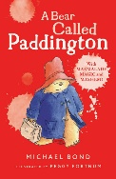  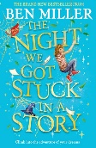  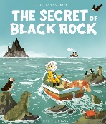  In our English lessons we will be reading The Secret of Black Rock. Children will learn how to structure a narrative while honing the use of punctuation and conjunctions to extend sentences We will then move onto writing a Non-fiction biography all about Nikola Tesla. Children will learn how to set out and structure their work within this genre. For guided reading children will improve their reading and comprehension skills by reading A Bear Called Paddington. Finally, during story time we will be reading the story; The Night We Got Stuck in a Story by Ben Miller. This magical adventure story is sure to spark the imagination.  RE  In our Religious Education lessons, we will focus on the key question: "What do Christians learn from the Creation story?” We encourage children to deepen their understanding of Christianity and to explore the themes of the creation story in more depth. Through nature walks, discussions, story telling and creative activities we will understand that as human beings are part of God’s good creation, they do best when staying close and listening to God’s guidance.  Jigsaw    Our PSHE Jigsaw topic is all about ‘Being Me in My World’. We will learn about how to be a good class team. How to be a school citizen and our rights and responsibilities within the classroom and school community.  Music  We will be learning and practising songs for the Harvest Festival through weekly Hymn practise. | Maths  Our Maths focus is Place Value looking at the value of each digit in a 4-digit number. We will find one, ten, one hundred and one thousand more than a given number. We will be using number lines and place value grid to support our understanding as well as looking at Roman Numerals. Following that we will move into Addition and Subtraction applying the skills we have previously learned.  Year 4 will be participating in the Multiplication Tables Check in June 2026. It is important that they continue to practise their tables using TT Rockstars.  Computing  Tho topic this term is Animation. Children will learn how to make a 2D animation using 2Animate. We will understand the term onion skinning and use this technique to make smoother transitions for our animations. By the end of the topic we will create a narrative through animation. Remember your child can access Purple Mash at home using their individual login- contact Miss F if you need a new copy/ instructions on this.  Art  Art will focus on drawing. We will explore tone, texture and proportion to create realistic drawings. We will create 3D effects by using contrasting tones to show light and dark. We will represent size of an object in relation to another object.  We will also be entering our self-portraits into the Gainford Village Art Exhibition in October. | Science  This half term we will learn about the importance of good eating habits to keep our digestive system happy and healthy. We will learn more about teeth and their uses along eith the importance of brushing carefully and conscientiously to prevent plaque. Finally, we will learn about food chains and classifying organisms into producers, predators and prey.  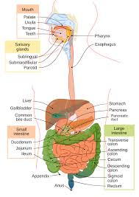  MFL    This half term, pupils will revisit some of the core language they learned last year such as asking and answering their name and where they live. They will learn classroom instructions, numbers to 20, names of days and months, and names of classroom objects.
 | History  Our history topic this term is Anglo-Saxons and Vikings. We will look at Why Anglo-Saxons decided to settle in England. We will look at the importance of Sutton Hoo and why achaelogical evidence cannot be one hundred percent certain. We will then look at why the Vikings settled in England and their links to the raids at Lindisfarne.  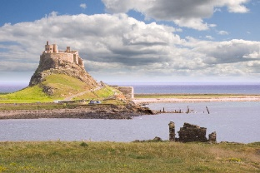 | PE    Physical Education (PE) lessons will focus on Tag-Rugby and Handball, promoting teamwork, coordination, and physical fitness, Children will develop their understanding of team play, positioning, and strategies, ensuring they grasp the fundamental rules of the games. We will also be heading to Staindrop for a the Tag-Rugby competition.
01325 730274 admin@gainfordcofeprimary.co.uk www.gainfordcofeprimary.co.uk

